What is AI Ethics ?

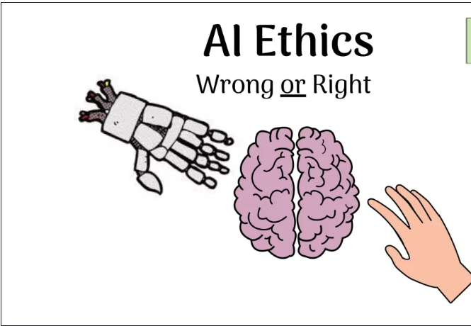

The discipline deals with right vs wrong and the moral obligations and duties of humans. It’s called AI ethics.

Ethics is the branch of philosophy concerned with grounding decisions, beliefs, policies, etc. In some sort of framework for deciding right or wrong. Ethics looks to resolve such questions as human morality. By deriving some moral system we can prescribe value to some action or beliefs.

Decisions are taken by all of the people who use this technology, it will be human decisions.

Ethical concerns of AI

Can AI assure this:

|  |  |
| --- | --- |
| Unemployment | What will happen after the end of jobs? |
| Inequality | How are we going to distribute the wealth created by machines? |
| Humanity | How do Machines affect our behaviour and interaction? |
| Artificial Stupidity | How can we guard against the mistakes? |
| Security | How do we keep AI safe from Adversaries? |

Taking over human jobs leading towards the era of Unemployment.

Making human less efficient , For example: asking everything from an artificial intelligent machine and making there own decisions.

Wealth inequalities , where wealthy people will become richer by the influence of machines where as poor people will become poor because of lack of jobs.

Machines will effect humanity and making them less interacting with other people.

Machines don’t know the desired output that humans want.

Facing racism from machines , which is also called [AI Bias](https://aiforkids.in/class-10/ai-ethics/#what-is-ai-bias)

At last, it depends on humans how they use technology and for what they use technologies, technology can become a blessing or curse depending on humans.

What is AI bias ?

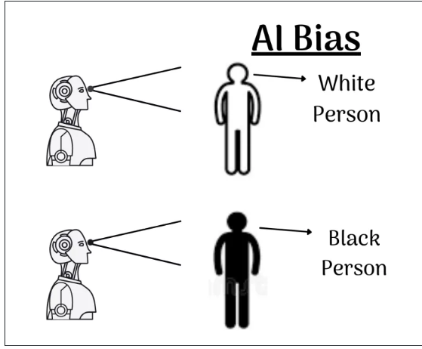

AI Bias means favoring someone or something. AI bias focuses upon training the machines with unbiased data, when Bias Data is fed to an AI Machine while creating the Model then the machine will also be biased.

The quality of your model is usually a direct result of the quality and quantity of your data.

Examples of AI Bias:

|  |  |
| --- | --- |
| Machine Voices | What will happen after the end of jobs? |
| Google Recommendations | How are we going to distribute the wealth created by machines? |
| Search Results | How do Machines affect our behaviour and interaction? |

We have seen that in most of artificial assistants have a female voice and not a male voice.

When a camera missed the mark on racial sensitivity, or when a software used to predict future criminals showed bias against black people.

Security systems are trained , based on an individuals race of gender rather than their actions ,movements to commit the crime ,etc. [Facial recognition](https://aiforkids.in/class-10/domains-of-ai/#facial-recognition) systems that look a diverse Training set ,resulting in only detecting the race for which they are trained.

AI bias Always collect data from authentic sources or unknown people and train the machines to avoid biasness in output

Court systems (AI judges/Juries) with past rulings against certain races as the training data.

**How to avoid AI bias?**

In simple terms AI access means making AI more accessible.

AI Access discusses the gap in society, where only upper-class people who can afford AI-enabled devices have the opportunity to access it and people below the poverty line don’t have access to it.

Because of this, a gap has emerged between these two classes of people and it gets widened with the rapid advancement of technology.

The Government has to bring balance in the society by providing infrastructure to common students/people so that everyone will get a chance to access emerging technologies like AI.

**What is Data privacy?**

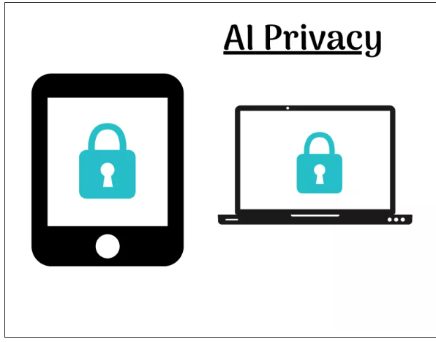

Data privacy is defined as one able to control how our digital data is being stored, modified, and exchanged between different parties.

As technology advances Artificial Intelligence becomes more and more integrated with every aspect of our lives. Numerous different industries use it to improve products and services but because machine learning often uses million of pieces of personae data to train the algorithms it is by strict privacy laws including EU GDPR or the California consumer privacy act. This means you need to protect your consumer’s data at all times.

**Should AI replace laborious jobs? Is there an alternative for major unemployment? this is an**

Open-ended question so both the answers (yes/No) are correct

Yes, AI should replace laborious jobs.  AI can replace laborious jobs like lifting of heavy items, working in mines etc.  AI can indeed automate most repetitive and physical tasks.

AI taking over laborious jobs won’t create unemployment. It is just a groundless fear. The standard view of technical change is that some jobs are displaced by the substitution of machines for labour, but that the fear of total displacement is misplaced because new jobs are created, largely due to the technology-fuelled increase in productivity..

**Should AI not replace laborious jobs? Will the lives of people improve if they keep on being unskilled?**

No, AI should not replace laborious jobs completely as if it replaces laborious jobs completely, then there will be no source of income for the daily wage workers due to unemployment. So, industry owners can use some machines but more of man power. Hence the production will not get affected as humans are smarter than machines since they were the ones who invented AI. Although lives of people do not improve if they keep on being unskilled. Unskilled people have difficulties in growth and personal development.

**Objective Type Questions (OTQs)**

1. ____________ can be defined as the science of moral duty and ideal human behaviour that teaches what is right and what is wrong. (**Ans. Ethics**)
2. ________ refers to the basic principles of AI system design that use a good code of conduct and produce the results. (**Ans. AI Ethics**)
3. Which of the following can be a simple objective system that depends on human judgement?
   1. **Logical Decision**
   2. Logical Data
   3. Logical Input
   4. Logical Access
4. Who is accountable for considering the system impact on the world?
   1. The system
   2. Only the developer
   3. Only the company
   4. **Every person involved in the creation**
5. If a smart self-driving car met an accident with a person on the road, who is responsible morally?
   1. The car owner
   2. The person
   3. **The developer**
   4. All of these
6. The major ethics concerns are
   1. issues, situations, choices
   2. **decisions, speeches, actions**
   3. feelings, thoughts, expressions
   4. All of these
7. AI ethics is a blanket term used for dealing with all the ethical issues related to AI. (**True**/False)
8. Which of the more important concern related to data?
   1. How does AI work?
   2. **How does AI take decisions?**
   3. How AI collects data?
   4. How does AI represent data?
9. The world of AI revolves around ___________. (Ans. **data**)
10. Which of the following is a major source of data for major companies?
    1. Our vehicles
    2. Our Home
    3. Our lifestyle
    4. **Our smartphone**
11. If you do not allow the app certain permissions like storage, phone, camera or contacts, you normally cannot access the features of the app. (**True**/False)
12. Which of the following information will be collected when you open the newly downloaded app on your mobile?
    1. Contact, Location, Camera, Storage
    2. Only contact and Camera
    3. Only Location and Storage
    4. **Any of the above depends on the app**
13. The AI system only performs the tasks exactly what they made for. (**True**/False)
14. AI systems are biased because they take decisions from the data and training material provided to them. (**True**/False)
15. __________ refers to the guideline and system purposes should be very clear to its users. (Ans. **Transparent System**)
16. The system should be designed in such a manner that the data collection and purpose should be unlimited. (True/**False**)
17. Amazon used a system for recruitment, created a situation in which many eligible females were left out of the consideration. This is called _________.
    1. Misinterpretation of Data
    2. **Problem of Inclusion**
    3. Gender Bias
    4. Data Privacy
18. Which of the following chatbot launched by Microsoft as an experimental Twitter chatbot?
    1. Twitterbot
    2. TwiChatBot
    3. **Tay**
    4. TwitterRobo
19. An AI system must have a right to the data it collects. (**True**/False)
20. The AI system cannot have any negative adoptions. (True/False)
21. The situation that is created by a system itself and the developer of the system cannot resolve them is known as __________. (Ans. **Black Box problem**)
22. Amazon had been working on a secret AI recruiting tool. The machine-learning specialists uncovered a big problem: their new recruiting engine did not like women. The system taught itself that male candidates were preferable. It penalized resumes that included the word “women”. This led to the failure of the tool. This is an example of
    1. Data Privacy
    2. AI access
    3. **AI Bias**
    4. Data Exploration

**Subjective Type Questions (STQs)**

1. **What do you understand by Ethics?**
   * The concerns related to good and ideal behaviour or manners and moral principles are known as ethics.
   * In other words, ethics refers to what is right and what is wrong then teaches moral conduct.
2. **What are the moral issues related to self-driving cars?**
   * Self-driving cars are totally under the control of AI.
   * For example, an animal is crossing your way suddenly hit by a self-driving car. The animal got hurt.
   * Who is responsible for this accident?
   * The following are some ethical concerns:
     + The developer of the car goes through all dilemmas while developing the car’s algorithm.
     + The morality of the developer gets transferred into the machine as what according to him/her is the right priority and hence would be the selection made by the machine.
     + Every person has their own perspective and he/she takes the decision according to their moralities.
3. **Why ethical practices should be followed while developing solutions using AI?**
   * Ethical practices are very important while developing solutions using AI because the solution is made to solve the problem or reduce the complexity of the problem.
   * If ethical practices are not followed properly then the solution might create more problems and that leads to more problems.
   * Even unethical practices increase risk and damage to the surroundings. Which is not a good cause for the problem solution.
4. **What are the concerns related to the use of AI to control defence** equipment?
   * AI-controlled nuclear missiles capable of making independent decisions or AI-equipped armed military drones.
   * Another concern is the human cost of the adoption of AI technology.
5. **What do you understand by data privacy?**
   * Data plays a vital role in AI systems. The existence of an AI system is impossible without data.
   * Data management like storage, usage, collection and maintaining data is one important concern.
   * When the user works on the system, the user is sharing data. This data needs permission to access the data. This consent is known as data privacy.
6. **Where do we collect data from?**
   * There are various platforms and sources we collect data from, some of them are:
     + Customers Feed Form
     + Loyalty Programs
     + Surveys
     + Service Agreements
     + Various contests or competition
     + Records of online transactions
     + Web browser cookies
     + Digital Footprints
     + Social Media
     + Keyword trackers
7. **Why do need to collect data?**
   * We need to collect data for the following reasons:
     + To store and analyse data
     + To know the potential of customers and get tangible returns
     + It helps for future marketing and increases engagement
     + It helps in retargeting efforts and increases database
     + It is helpful for making an overall strategy and improving the products
     + It is helpful in obtaining feedback from customer
8. **“Smartphones are major sources of data nowadays.”** **Justify this statement.**
   * Smartphones becomes an integral part of human lives nowadays.
   * Most of us use smartphones more than we interact with people around us.
   * This is because smartphones provide a lot of facilities and features that make human life easy and comfortable.
   * With online shopping, ordering food becomes very easy with the help of small box loaded with technology.
   * Moreover, now smartphones provide recommendations and notifications according to users’ choices.
9. **Priya and Rani are friends. Rani wants to buy a new purse. They discussed on WhatsApp about purchasing a new purse online. After discussion, what will happen to Rani’s phone?** **Why?**
   * After the discussion, the smartphone starts showing the recommendations to buy a new purse.
   * The shopping websites show notifications related to branded purses.
   * They show and urge rani to buy a new purse.
10. **How does the smartphone get to know about the discussions and thoughts that the mobile user has?**
    * As a mobile user when people download and install apps from the play store, it asks a few questions and permission’s access the phone’s data in different ways.
    * Once the user allows it the AI system of a particular app, starts working on the data collection.
    * It understands the behaviour, and data and recommends the user product or services accordingly.
11. **Majorly, all the virtual assistants have a female voice. It is only now that some companies have understood this bias and have started giving options for male voices but since the virtual assistants came into practice, female voices are always preferred for them over any other voice. What are some reasons for this?**
    * As per the general observation, virtual assistants are developed for assistance.
    * The female voice is more soothing compared to a male voice.
    * In addition to this, Virtual Assistants should be more user-friendly.
    * One reason behind this the company makes the user listen to their voice. So they thought female voice will be better than male.
12. **Aman has searched on Google for salons, the first few searches he found mostly salons for female salons. This is based on the assumption that if a person is searching for a salon, in all probability it would be a female. Do you think this is a bias? If yes, then is it a Negative bias or a Positive one?**
    * It is a negative bias.
    * The reason for this is generally the algorithm understands that women are visiting salons more than men.
13. **What is the permission asked by the app before using it?**
    * The following permissions are required to be asked by the app before using it:
      + Contacts
      + Location
      + Camera
      + Storage
      + Photos
      + Notes
14. **What are the components of a good AI Policy?**
    * Transparent Policy – Clear guidelines and purposes for users
    * Right of data collection – The data collected by the AI system must be right to the data
    * Freedom of leaving the system – The freedom to leave the system anytime should be given to the user
    * Design – The design should be done in such a way that data collection and purpose should be limited
    * Data deletion – Data stored by users should be deleted when they leave the system
15. **AI increased the gap between two classes of people. Which are these two classes of people?**
    * AI is an emerging technology as well as budding technology.
    * Not everyone has the opportunity to access it.
    * The two classes of people are:
      + People who can afford AI-enabled devices make the most of it
      + The people who can’t afford Ai-enabled devices left behind
16. **“In the coming years, AI-enabled machines will replace all the people who work as labourers.”** **Justify this statement.**
    * As per one thought, AI makes our life easier.
    * People want most things in just one click and some platforms provide that too.
    * So AI enables machines or devices will do the task with just a click.
    * Where for the same task human being takes more time compared to AI machines.
    * So people who have little or no skills may be left out without jobs and AI takes charge.
17. **Should AI not replace laborious jobs? Will the lives of people improve if they keep on being unskilled?**
    * AI should not replace all laborious jobs. As if so, there will be no source of income for the daily wage workers.
    * Although lives of people do not improve if they keep on being unskilled. Unskilled people have difficulties in growth and personal development.
    * Unskilled employees are also obstacles to the organization’s growth as well. So employees need to be trained in new skills on regular basis.
18. **Why AI models are biased in one or another way? Explain it.**
    * As we are humans, have our own biases towards things.
    * Biases are not negative all the time.
    * Sometimes it is required to have a bias to control a situation and things working.
    * Similarly, machines can have intelligence but not their own bias.
    * Any bias can transfer from the developer to the machine through the algorithm.
    * So they are working according to the algorithm. So they are biased in one or another way.
19. **Is it ethical that children** **to** **use technology to help to finish their study-related work?**
    * The use of technology by children is making them smart and techno-savy.
    * At the same time, they can misuse that and learn what is not important to them.
    * Sometimes technology kills their creativity and they don’t think on their own.
    * Hence at one side technology can be used for learning or doing work smartly but not all the time.
20. **What do you understand about the problem of inclusion?**
    * The problem of inclusion refers to the problem that some people are left out of the AI decision-making system.
    * Here we have a great example of AI problem inclusion.
    * Amazon has started the recruitment process through AI, but the AI system left many eligible females into consideration.
21. **What do you understand by the fact interpretation?**
    * The AI system can collect the facts or scan data and learn from it but is not able to understand the reason behind a particular conclusion or learning.
    * Sometimes the AI system learns negatively also and produces the result in the same manner.
    * This is called fact interpretation.
22. **What is “Tay”? What controversies were created by Tay?**
    * The “Tay” is a chatbot developed by Microsoft to run on the Twitter social media platform.
    * It was designed to experiment with conversational understanding.
    * As per Microsoft’s claim, with more users, Tay will be smarter and learn to engage people through casual and playful conversations.
    * The controversy started after the launch of Tay.
    * In the first 24 hours of the launch of Tay, it learned from thousands of tweets and developed an unethical personality.
    * It just started mimicking the personality talking to it and learned from the data fed into it without interpreting it.
23. **What are the major AI ethical concerns related to AI adoption?**
    * Unemployment
    * Inequalities
    * Negative Adoptions
    * Black Box problem